

1. False, there also can see software products.
2. True, the products include Pcs , desktops , laptops.
3. False, there exhibit latest hardware products as well and other it solutions and apps for education , health etc. ( need to write all)
4. True, it mention that .
5. True

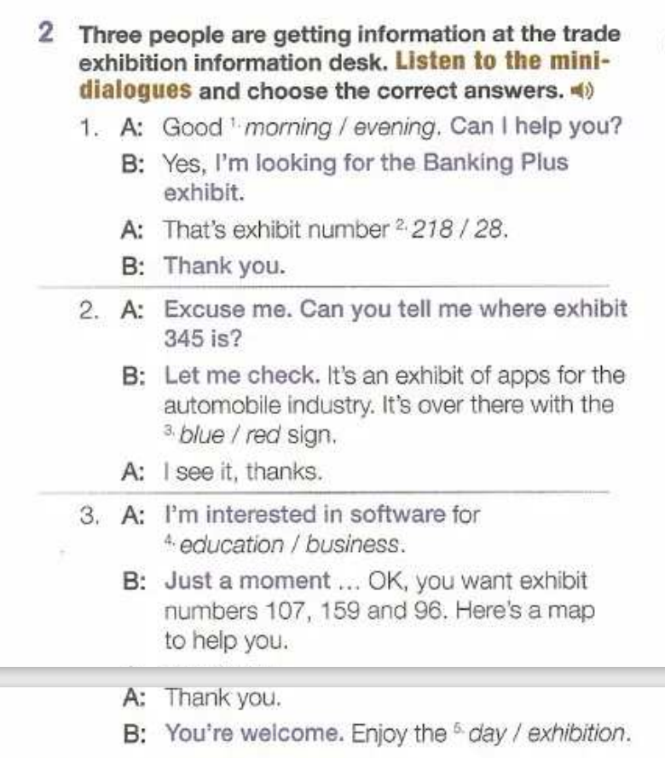

Morning

218

red

education

exhibition

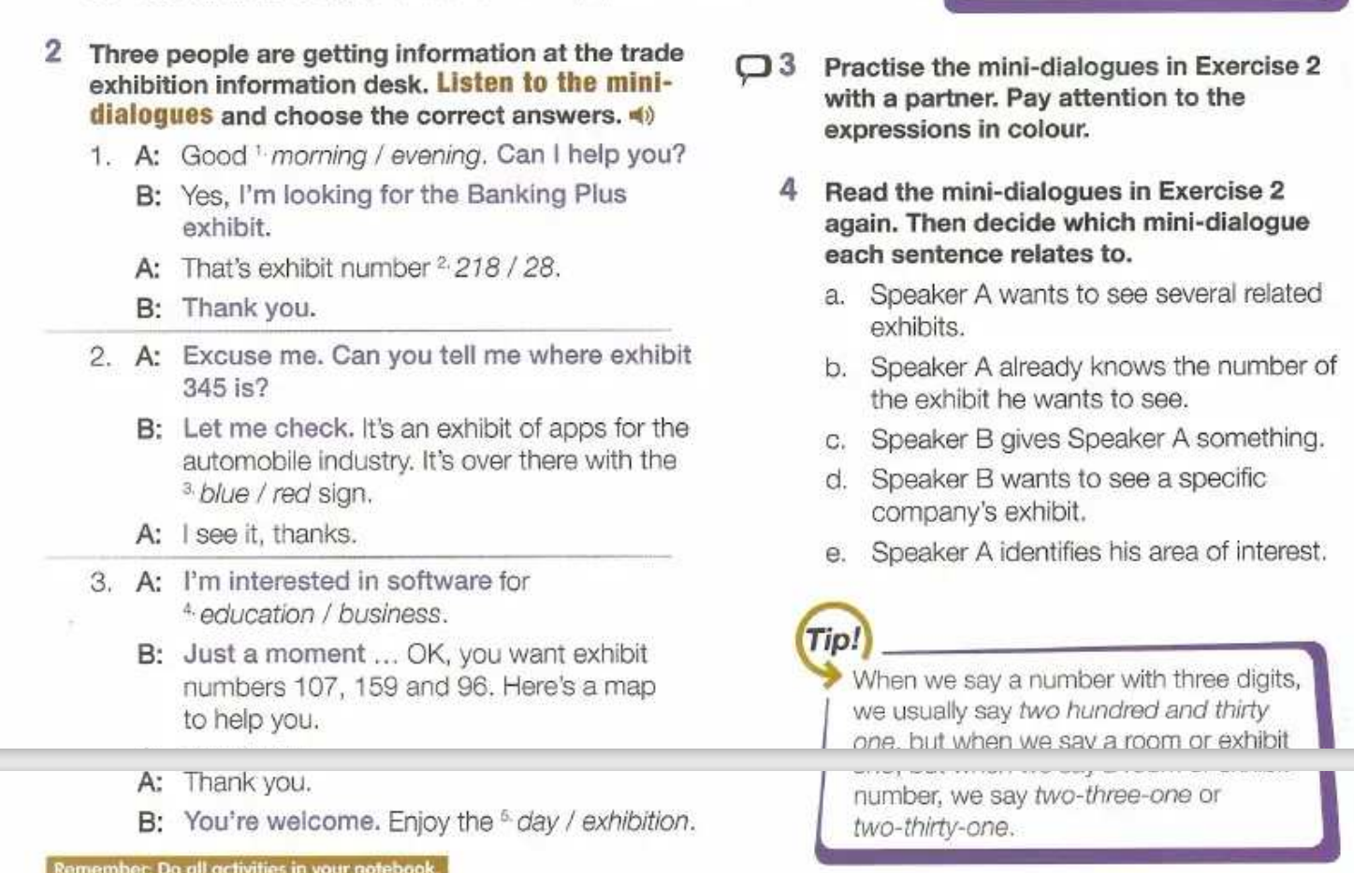

3-a

2-b

3-c

d-1

3-e

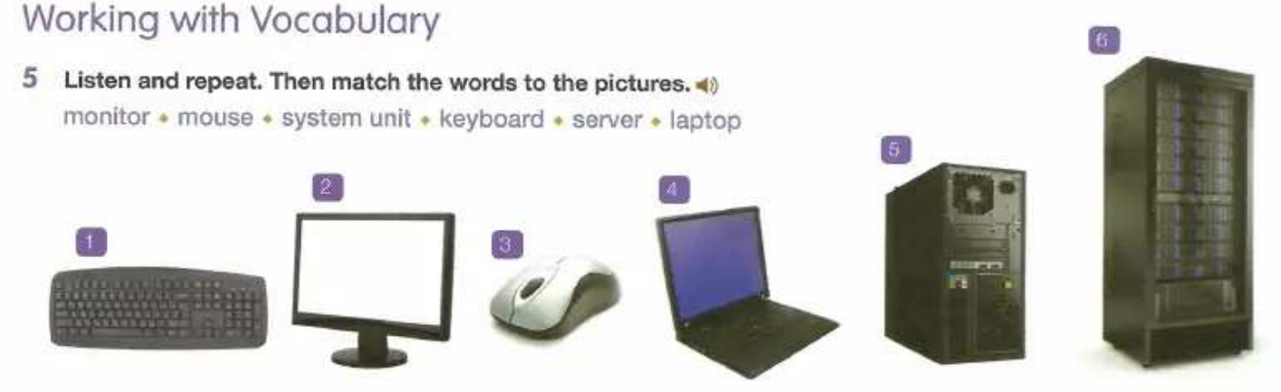

1. Keyboard
2. Monitor
3. Mouse
4. Laptop
5. System unit
6. Server

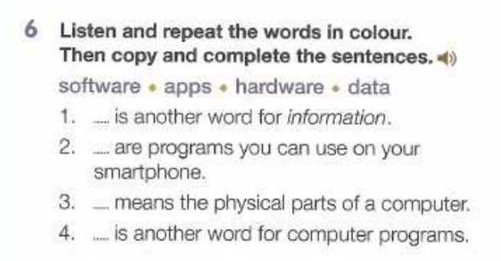

1. data 2.apps 3.hardware 4.software

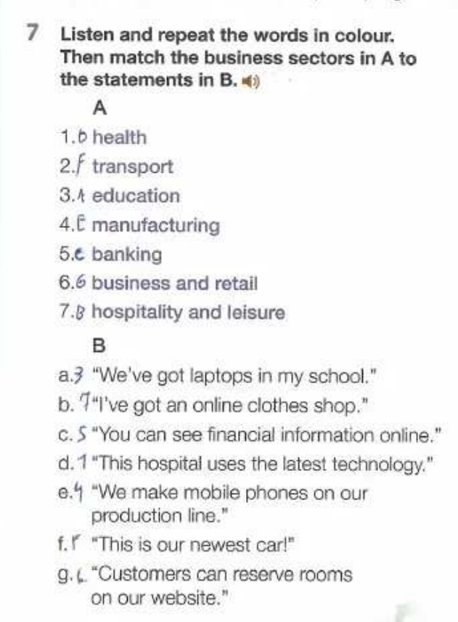

1-d 2f 3a 4e 5c 6b 7g

1,300 mil 1.3 = 1,3 en español

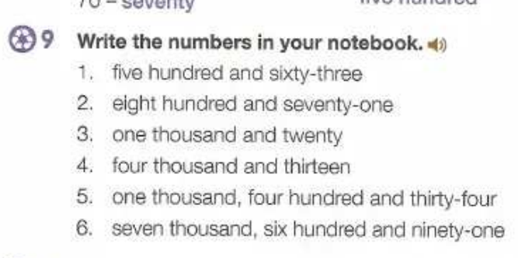

563

871

1,020

4,013

1,434

7,691

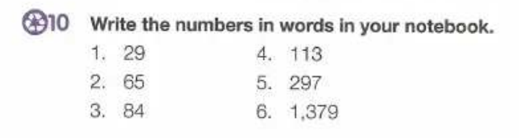

Twenty nine

Sixty-five

Eighty-four

One hundred and thirteen

Two hundred and ninety-seven

One thousand three hundred and seventy-nine

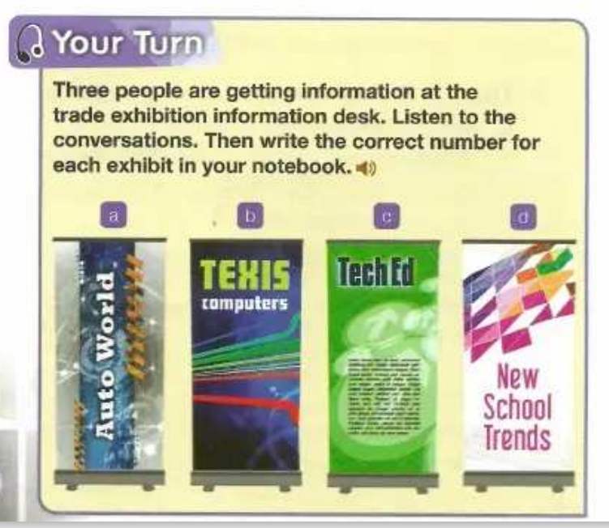

A 240

B 94

C 176

D 167

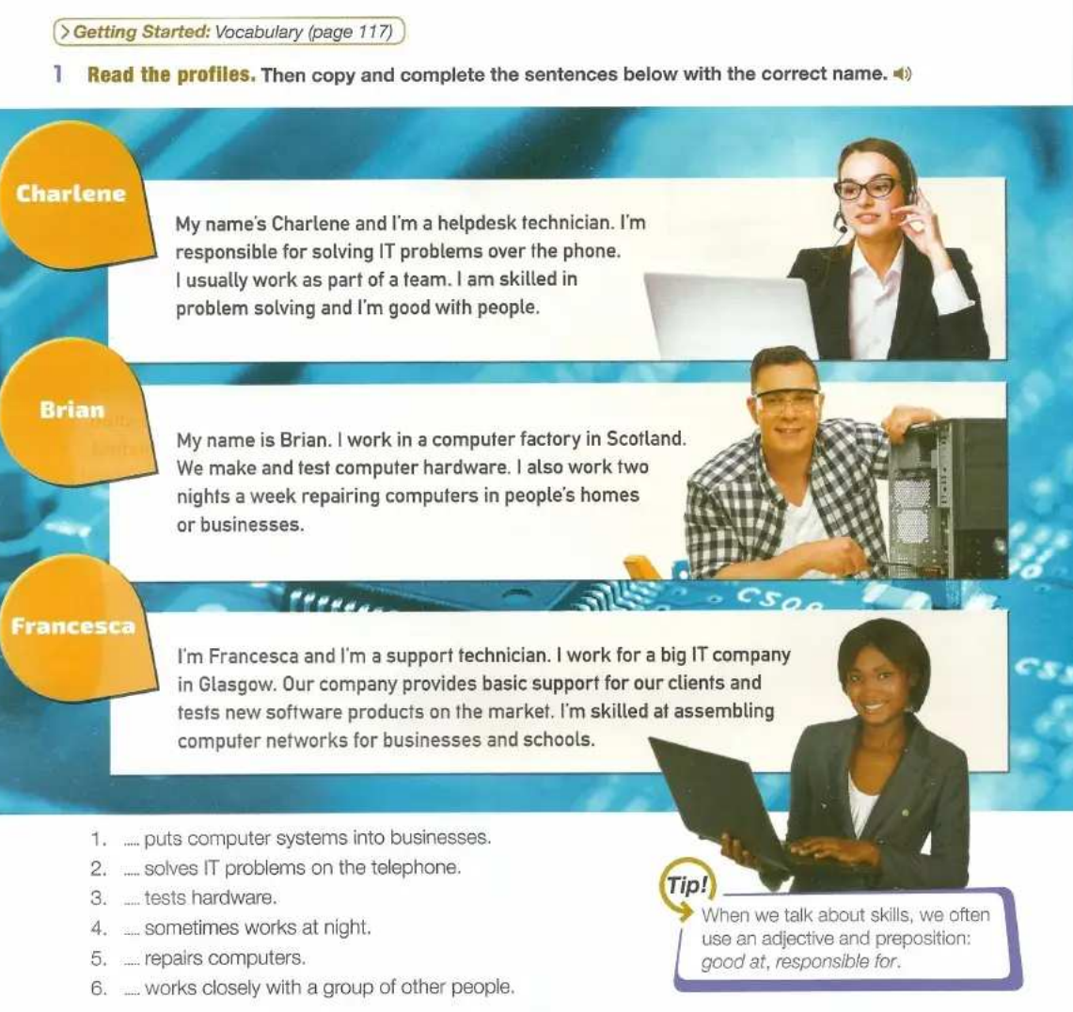

Over the phone / on the phone

1.francesca

2. Charlene

3.brian

4.brian

5.brian

6.charlrne

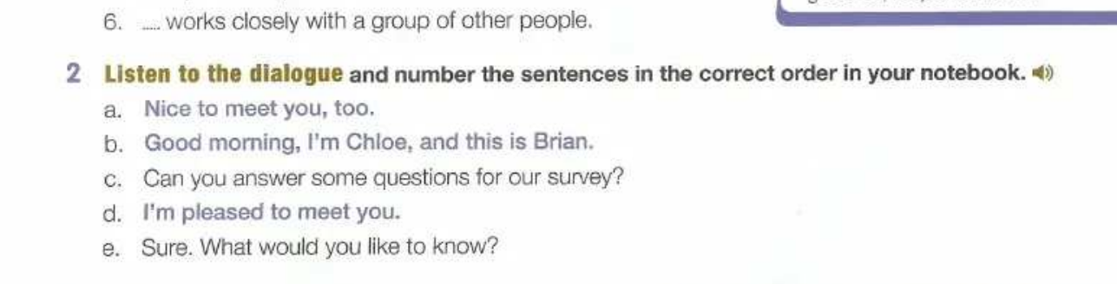

B,d,a,c,e

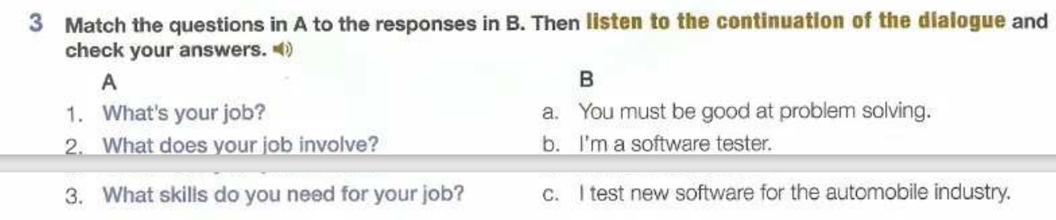

1-b 2-c 3-a

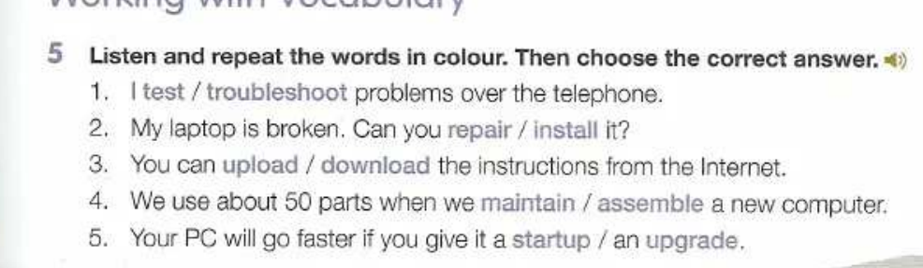

1. troubleshoot 2.repair 3.download 4.assemble 5.upgrade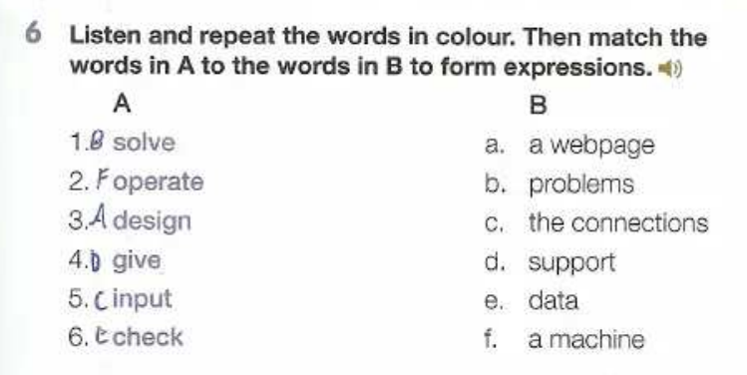

solve problems ,

operate a machine

design a webpage

give support

input data

check the connections

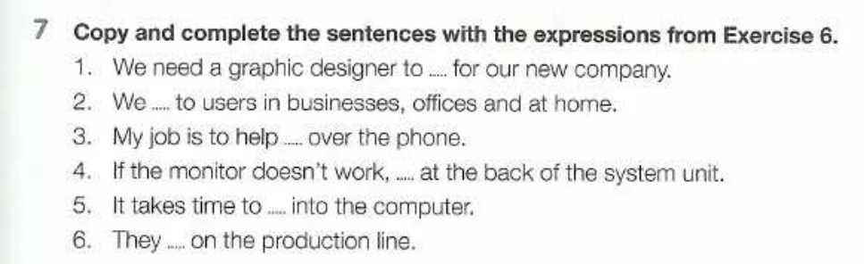

1.webpage 2.give support 3.solve problem 4.check the connections 5.input data

6. operate a machine

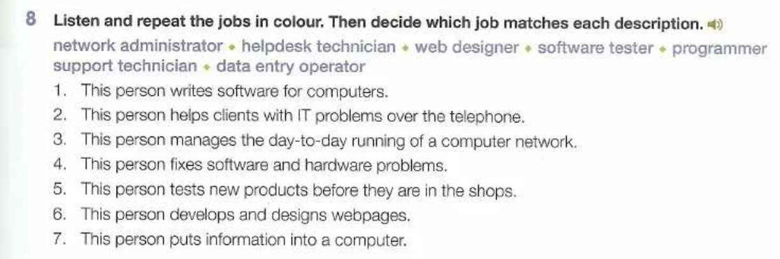

1. programmer
2. helpdesk technician
3. network administrator
4. support technician
5. web designer
6. data entry operator

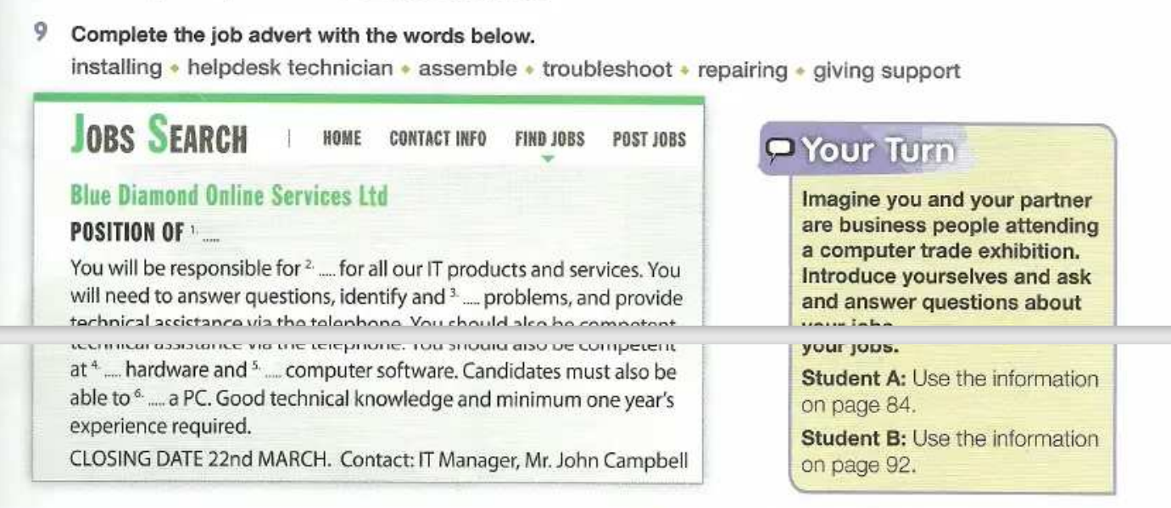

1. helpdesk technician 2.giving support 3.trubleshoot 4.repairing 5.installing 6 assemble.

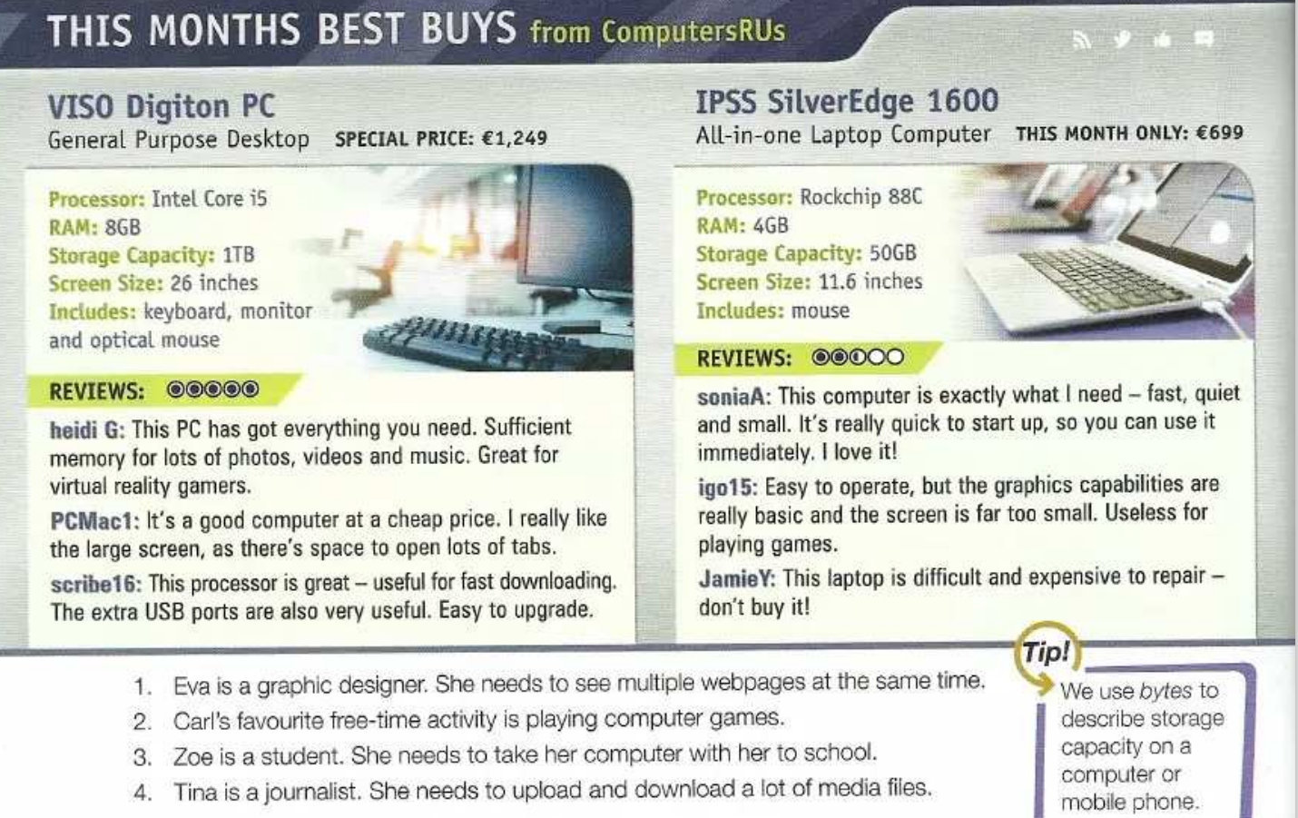

1-1 tab - pestaña web

2-1

3-2

4-1

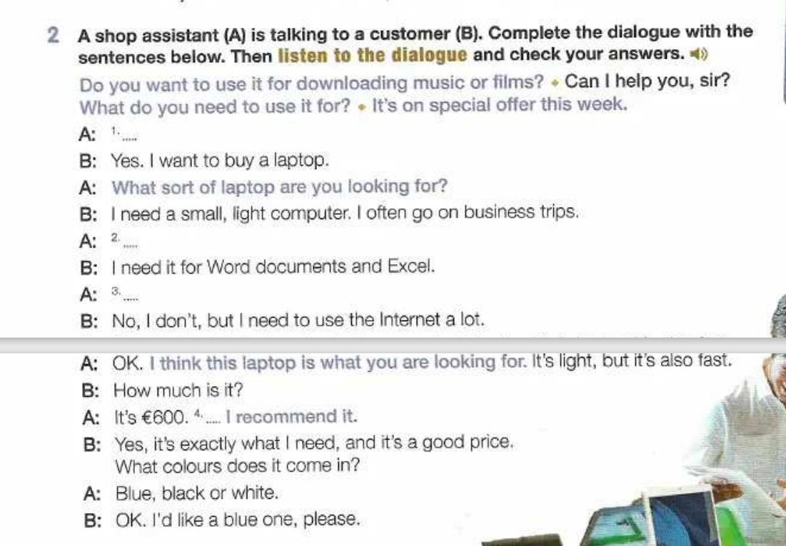

1. can I help you,sir?
2. What do you need to use it for?
3. Do you want to use it for downding music or films?
4. It’s on special offer this week

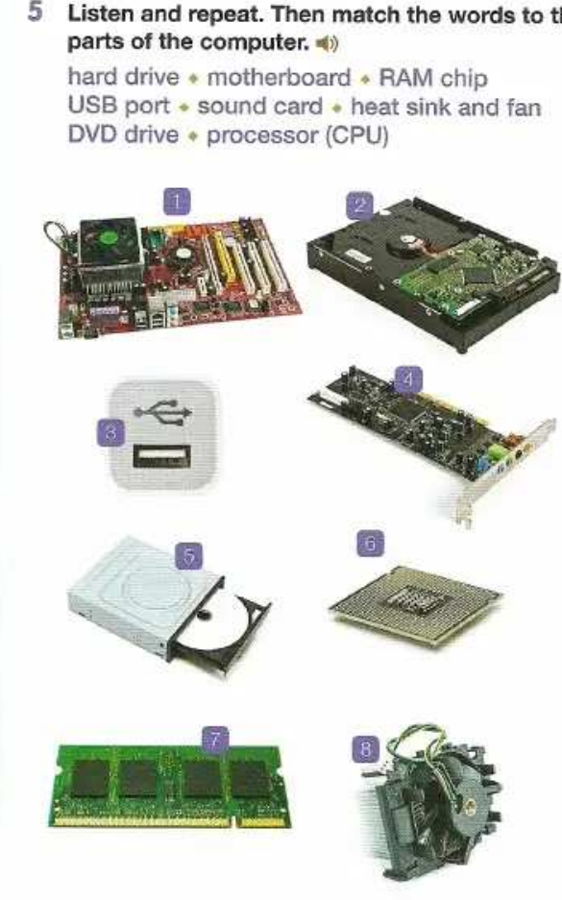

1. motherboard
2. hard drive
3. usb port
4. sound card

5.dvd drive

6.processor

7.ram chip

8.Heat sink and fan

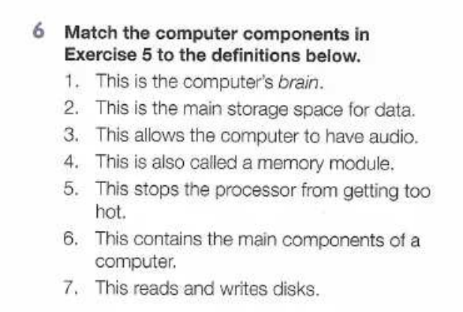

1. Processor (cpu)
2. Hard dive
3. Sound card
4. Ram chip
5. Heat sink and fan
6. Motherboard
7. Dvd drive

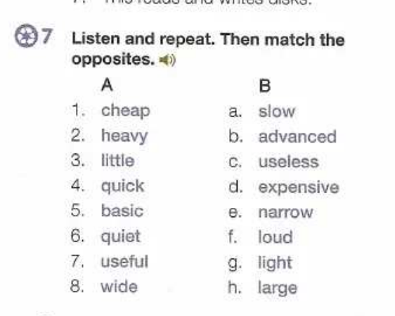

1. D cocacola light – diet coke
2. g
3. h
4. a
5. b
6. f
7. c
8. e

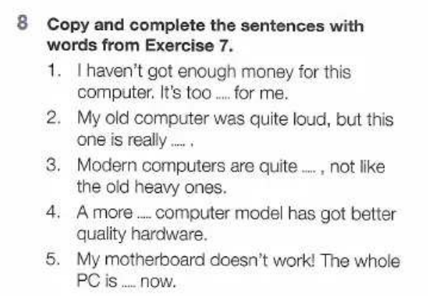

1. expensive
2. quiet
3. light
4. advanced
5. useless

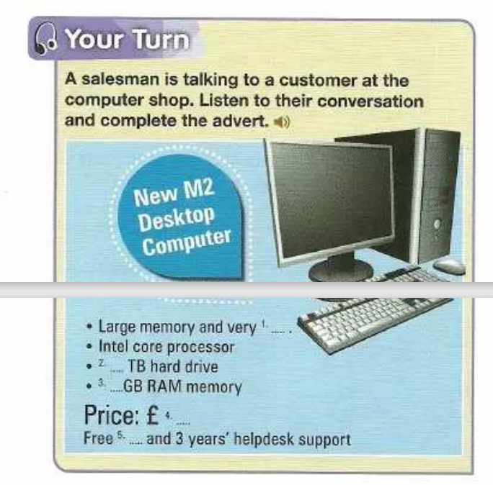

1. fast

2.2tb

3.4gb

4.490

5.mouse

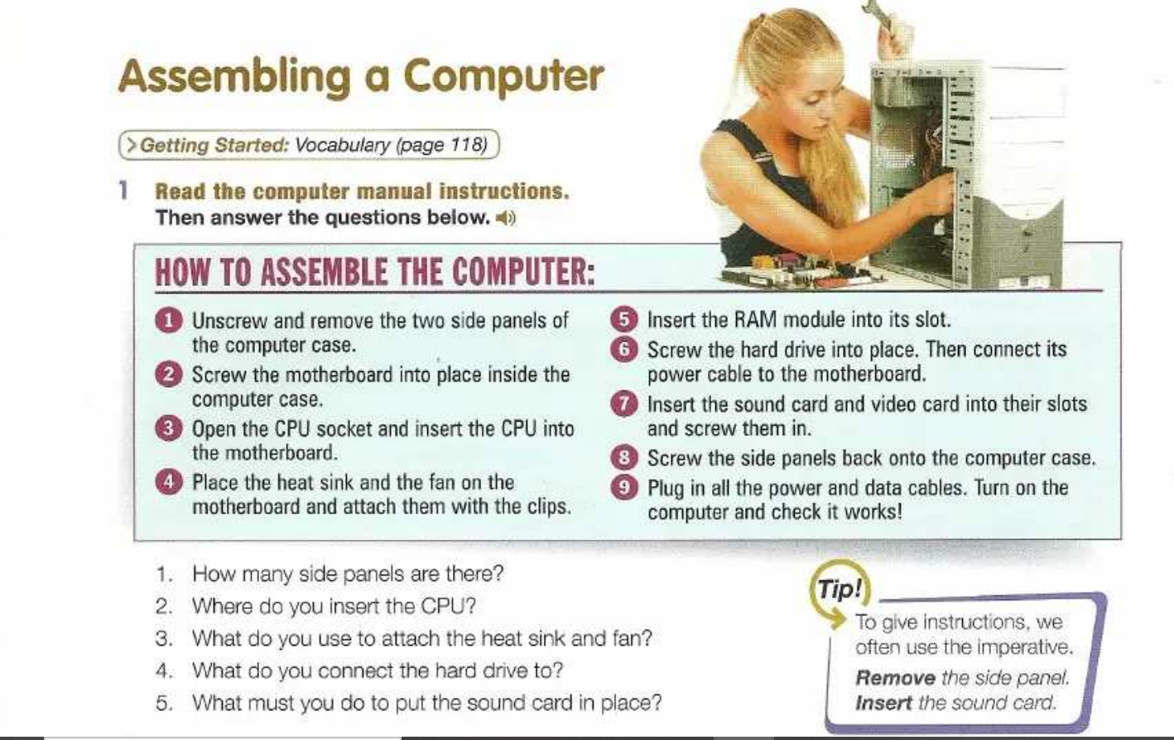

Screw-Unscrew – desatornillar

Plug-unplug

module

1. two
2. into motherboard
3. using clips
4. to the motherboard
5. insert it into its slot and screw it in.

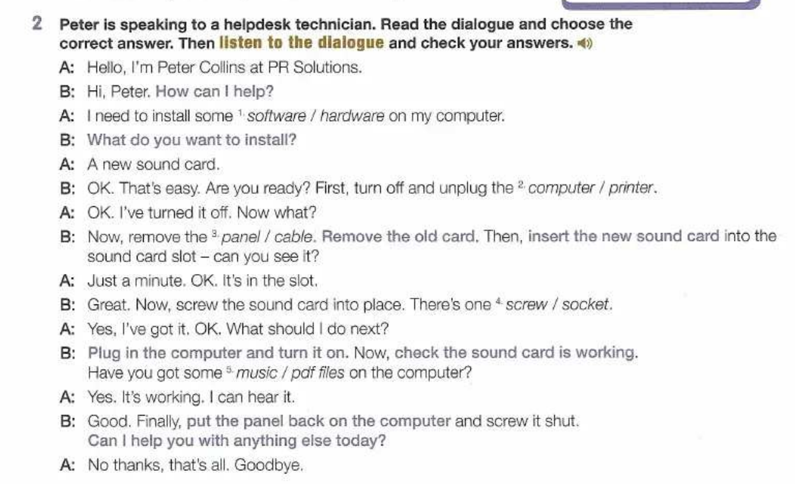

Hardware,computer,panel,screw,music

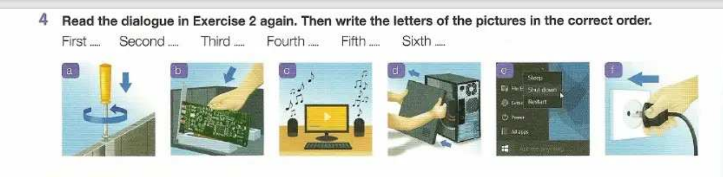

1st,2nd,3rd,4th,5th,31st,22nd

E. turn off

D. remove panel,

B. insert the new sound card into the slot,

A. screw it,

F. plug computer

C. it works for playing music.

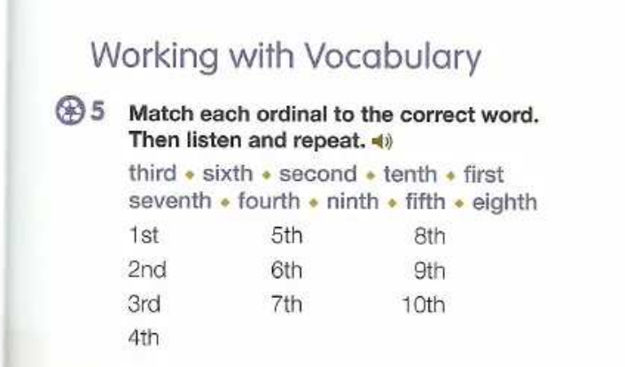

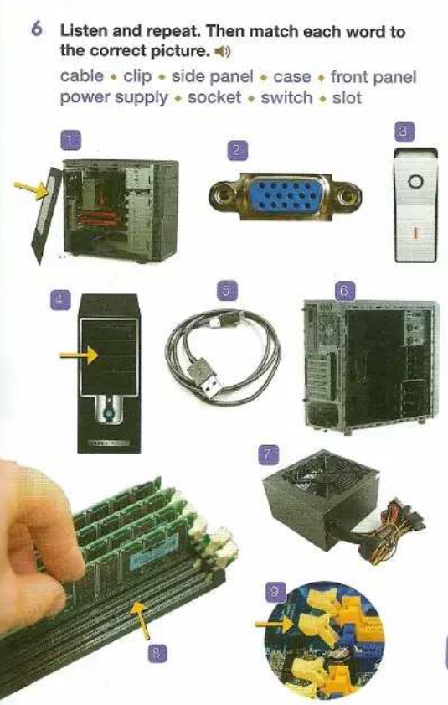

1. side panel
2. socket
3. switch
4. front panel
5. cable
6. case
7. power supply
8. slot
9. clip

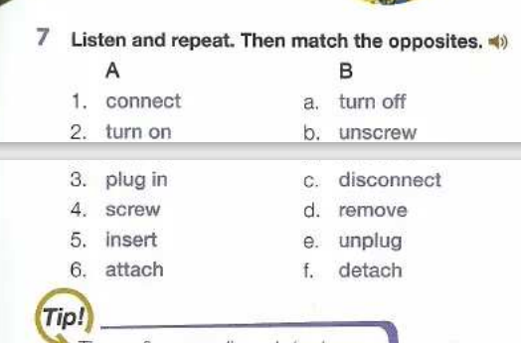

Connect - disconnect

Turn on- turn off

Plug in – unplug

Screw – unscrew

Insert – remove

Attach- detach

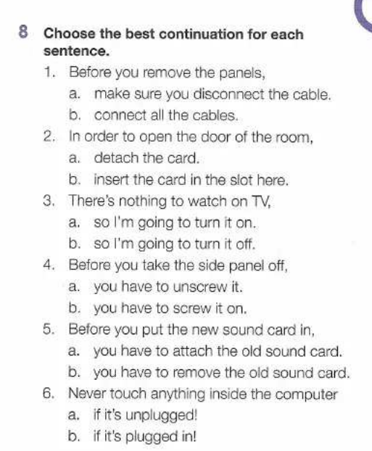

1-a 2-b 3-b 4-a 5-b 6-b

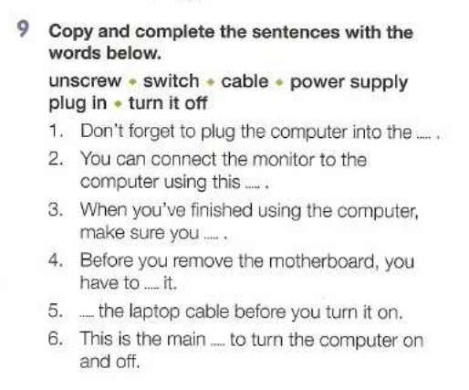

1. power supply
2. cable
3. turn it off
4. unscrew
5. plug in
6. switch

U11



1.c 2. e 3.b 4.f 5.a 6.d

Brochures

Memos :

Embedding:

Spreadsheets:

Worksheets

Reminder

e-mailing

attachment

cc

bcc

file archivo

folder carpeta